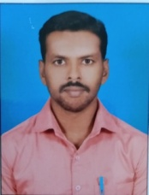

**STAFF PROFILE**

|  |  |  |  |  |
| --- | --- | --- | --- | --- |
| Name | | : | **Mr.M.SENTHILKUMAR** | |
| Designation | | : | **Sports Trainer** | |
| Qualification | | : | **B.A.,B.P.Ed.,M.P.Ed.,M.Phil.,Ph.D** | |
| Experience | | : | **2 Year 2 Months** | |
| **Sports Achievement** | | | | |
| Secured third place in inter collegiate 800 mts in the year 2010-2011 College of Physical Education Allagappa University Karaikudi. | | | | |
| Runners up in inter college Ball Badminton competition in the year 2010-2011 College of Physical Education Allagappa University Karaikudi. | | | | |
| Winner up in the state level inter collegiate Kabaddi Rolling trophy tournament held at Tamil Nadu Physical Education and Sports University Chennai. From 26th to 28th Feb 2013. | | | | |
| Participated in inter collegiate Kho-Kho tournament in the year  2010-2011 College of Physical Education Allagappa University Karaikudi. | | | | |
| Participated in inter collegiate Hockey tournament in the year 2011-2012 Tamil Nadu Physical Education and Sports University Chennai. | | | | |
| **Publication** | | | | |
| **Particulars** | **International Level** | | | **National Level** |
| Journals | 01 | | | xx |
| Conference | 02 | | | xx |